**CREATION OF IBM WATSON IOT PLATFORM AND DEVICES**

|  |  |
| --- | --- |
| TEAM ID | **PNT2022TMID24852** |
| PROJECT TITLE | IoT BASED SMART CROP PROTECTION SYSTEM FOR AGRICULTURE |
| DATE | 30 October 2022 |

IBM Watson IoT platform acts as the mediator to connect the web application to IoT device, so create the IBM Watson IoT platform. In order to connect the IoT device to the IBM cloud, create a device in the IBM Watson IoT platform and get the device credentials.

**STEP 1:**

• Login in cloud account.

• In dashboard click on catalog.

• Search for internet of things platform

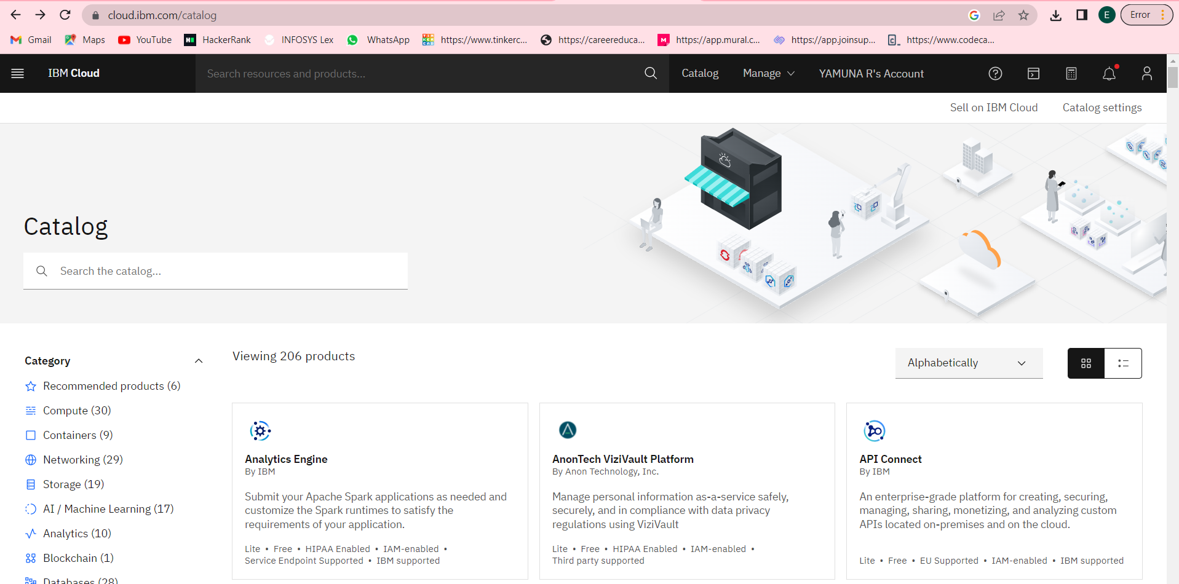

**STEP 2:**

• Click on launch

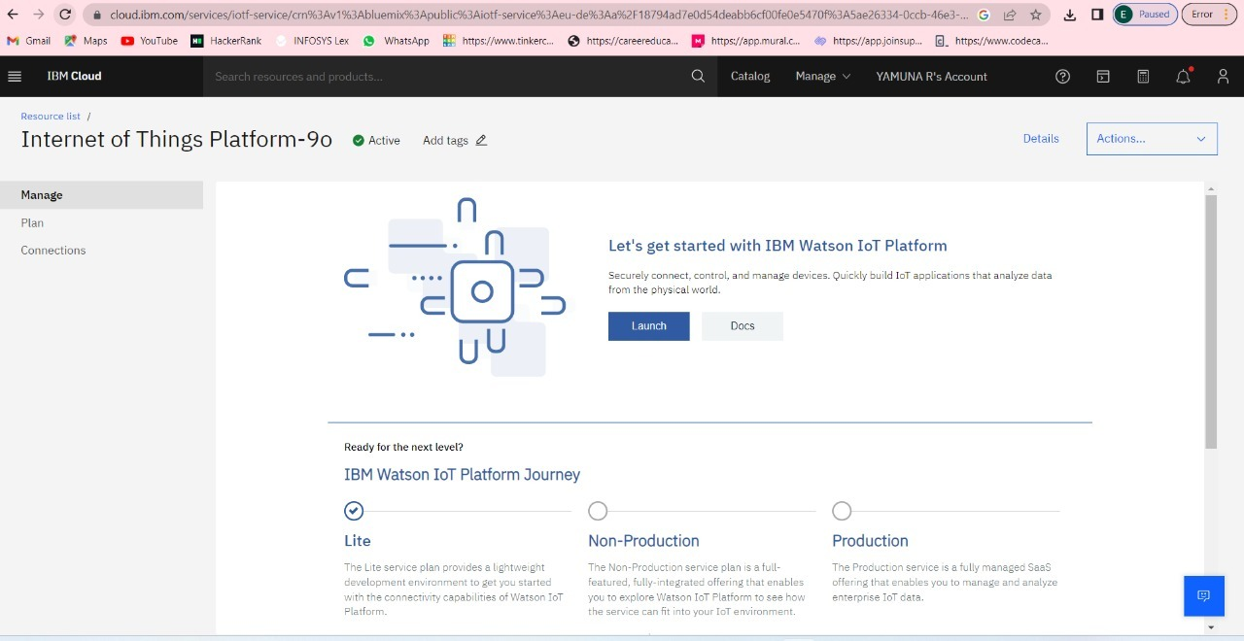

**STEP 3:**

• Sign in and select the org id

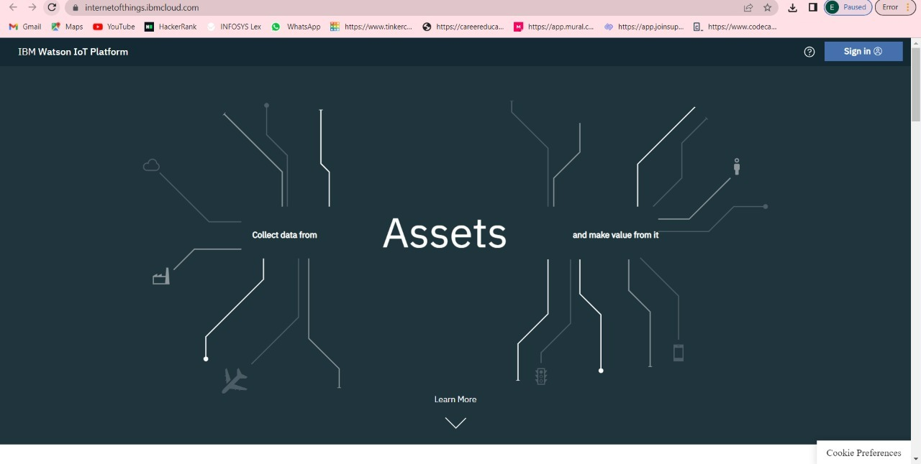

**STEP 4:**

• Will launch the browse device.

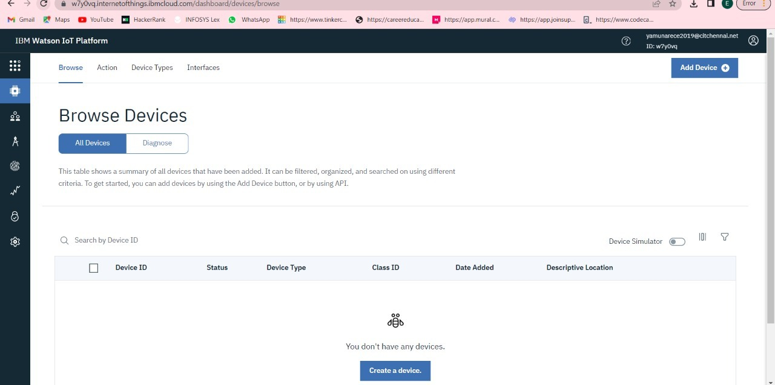

**STEP 5:**

• Click on add device

